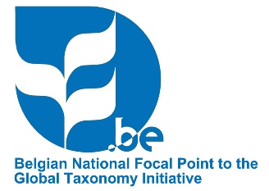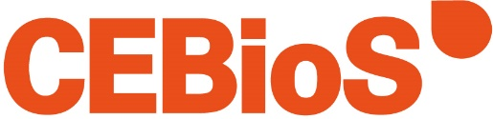

ACTIVITY REPORT
GTI Capacity Development Grant 2023
Completed reports must be sent to cbd-gti@naturalsciences.be at the latest two months after the last mission of the project and no later than the date specified in the Memorandum of Understanding.
PART I – Summary
CEBioS reference (see contract or MoU)
Title of the project
Promoter (name and contact details)
Partner institute(s) in the South (name and contact details)
Scientific domain
Short summary of the project (max 500 words)
Start and end date of the project
Approved budget (CEBioS)
PART II – Participants
Specify how the participants from the partner country were selected (the target group for the capacity development component) and what was their background.
Were there other actors involved from developing countries, other than the participants (e.g., guest speakers, experts)? What was their contribution?
PART III – Objectives
What were the expected outcomes of the project, i.e., the specific, short-term objectives, and to what extent have they been met? Explain.
What are the concrete outputs / deliverables of the project? Please use (and further specify) SMART indicators: number of people trained, number of (expected) publications, course / awareness / communication material produced, etc.
PART IV – Activities
Please provide in Annex 1 a detailed overview of the activities that took place in the partner country (programme per day, if possible)
Could the planned activities be realised? What are the obtained results, reasons for success or failure, encountered difficulties, etc.?
What has been the added value of this project compared to the previous project (if applicable) or to past collaborations with the partner country / institute(s)?
PART V – Impact & Sustainability
If the participants were given the opportunity to evaluate the project / training, please attach the results as an annex. How and by whom was this evaluation organised?
Indicate to what extent the taxonomic and/or curatorial needs of the partner country / institute(s) have been met. How has the project contributed to strengthening individual and/or institutional capacities?
To what extent has the project raised opportunities for new or follow-up initiatives? What are the future perspectives?

ANNEX 1
Detailed programme of the activities (free format)

SMART indicators are Specific, Measurable, Achievable, Relevant and Time-bound

